**MY LEARNING PATH**

*By Diep Truong*

I started out by learning through Udemy, taking several courses in *Web Developer Bootcamp* and *the complete JavaScript course*. In the *Web Developer Bootcamp course*, I focused on HTML, CSS, and Bootstrap. Learning HTML and CSS was such a fun experience because I could quickly write and modify simple pages. I found that Bootstrap very convenient because I did not have to write my own CSS for buttons or navbar.

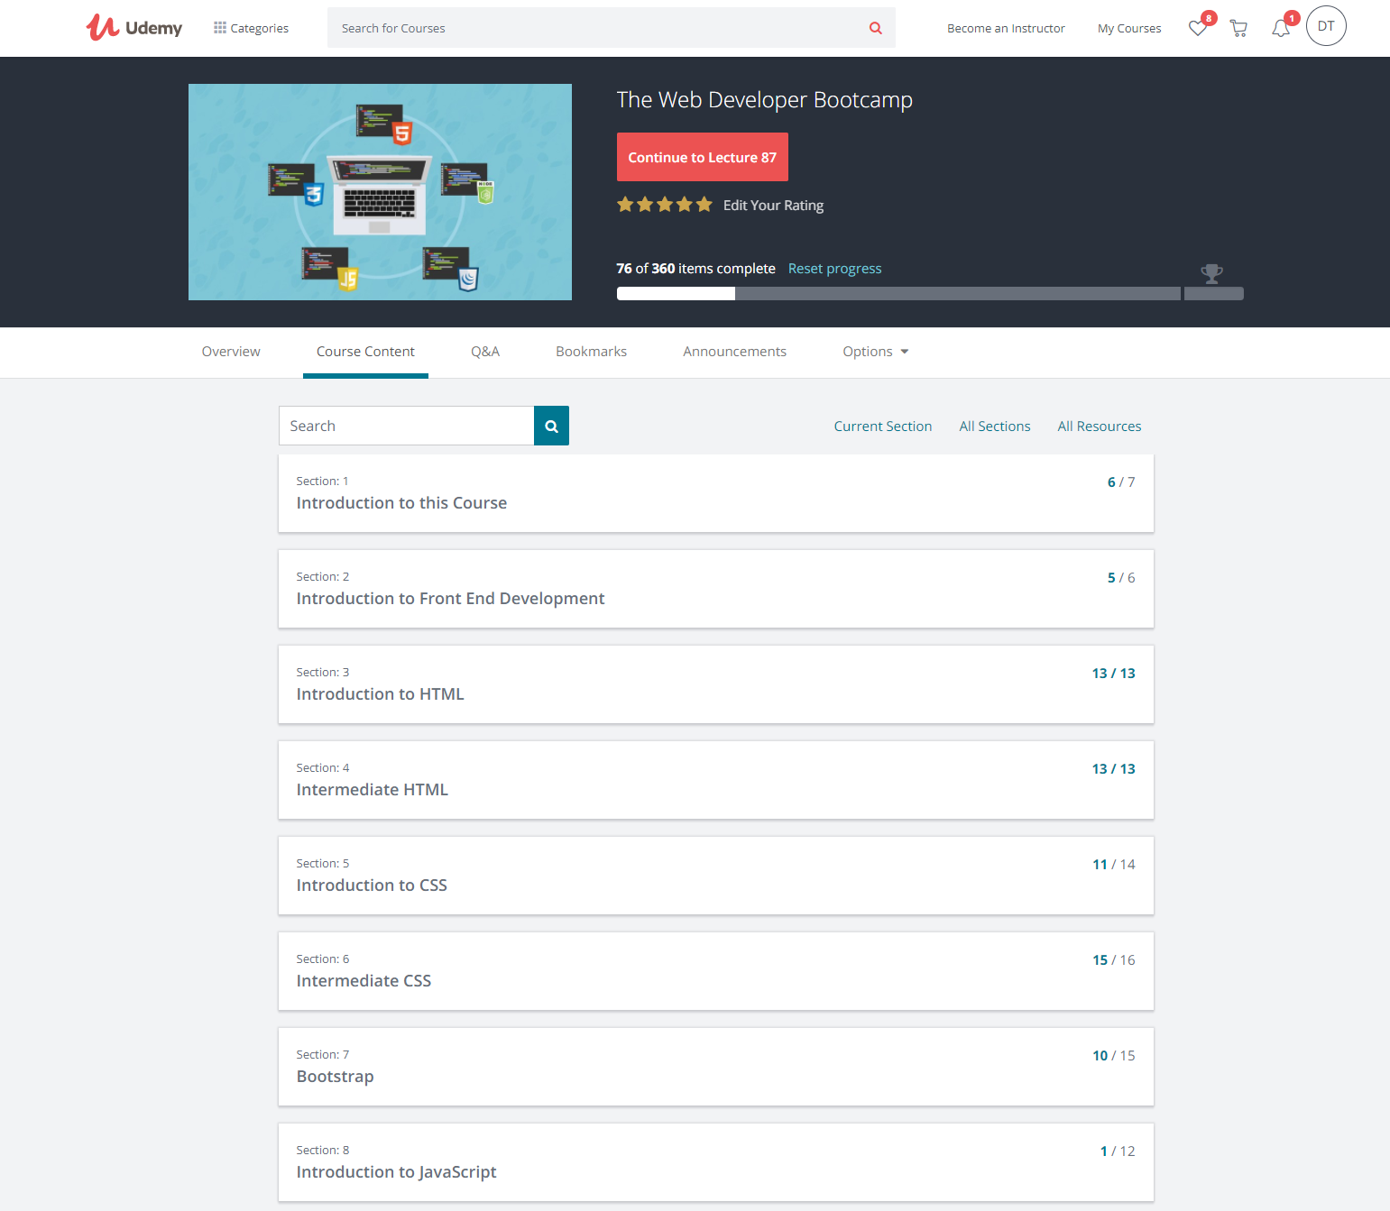

This is a food blog page that I made very quickly after learning the basics.

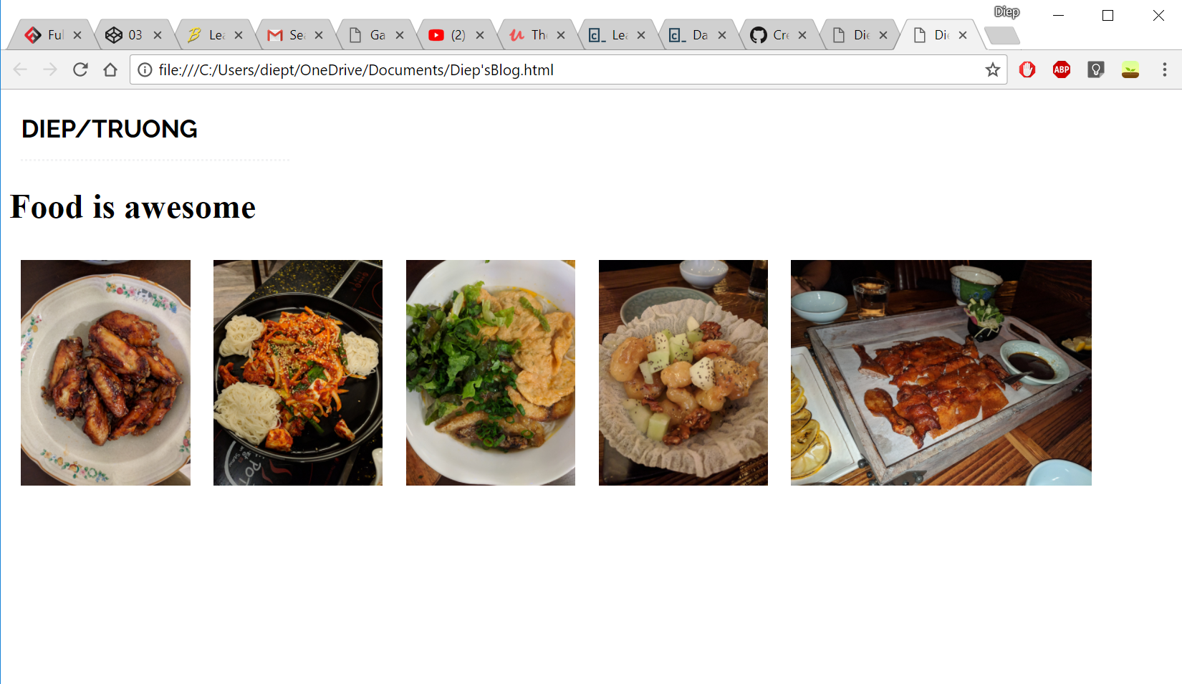

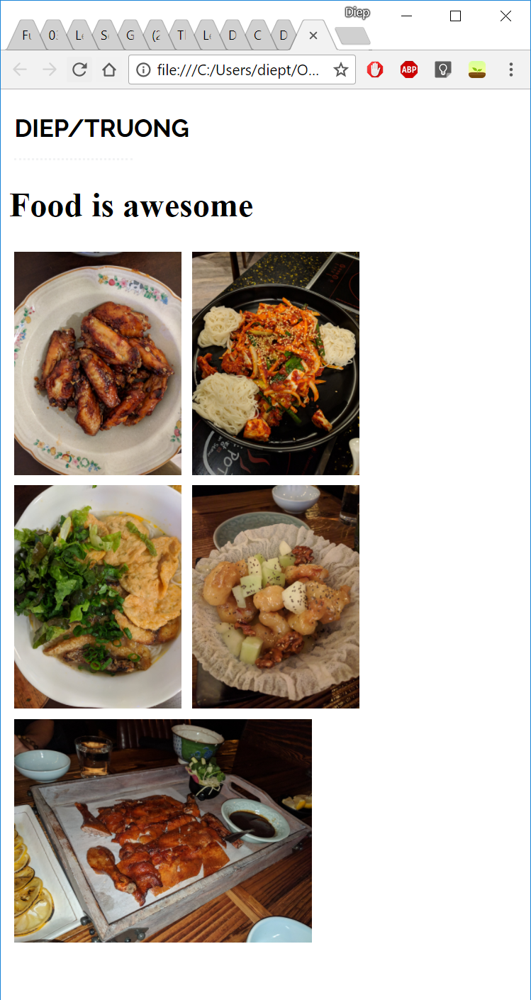

After learning some HTML and CSS, I spent time on learning JavaScript. I completed my first JavaScript course through Codecademy. This site was very helpful for me to learn the basics of JavaScript. The quizzes were fun for me to apply the knowledge that I had just learned.

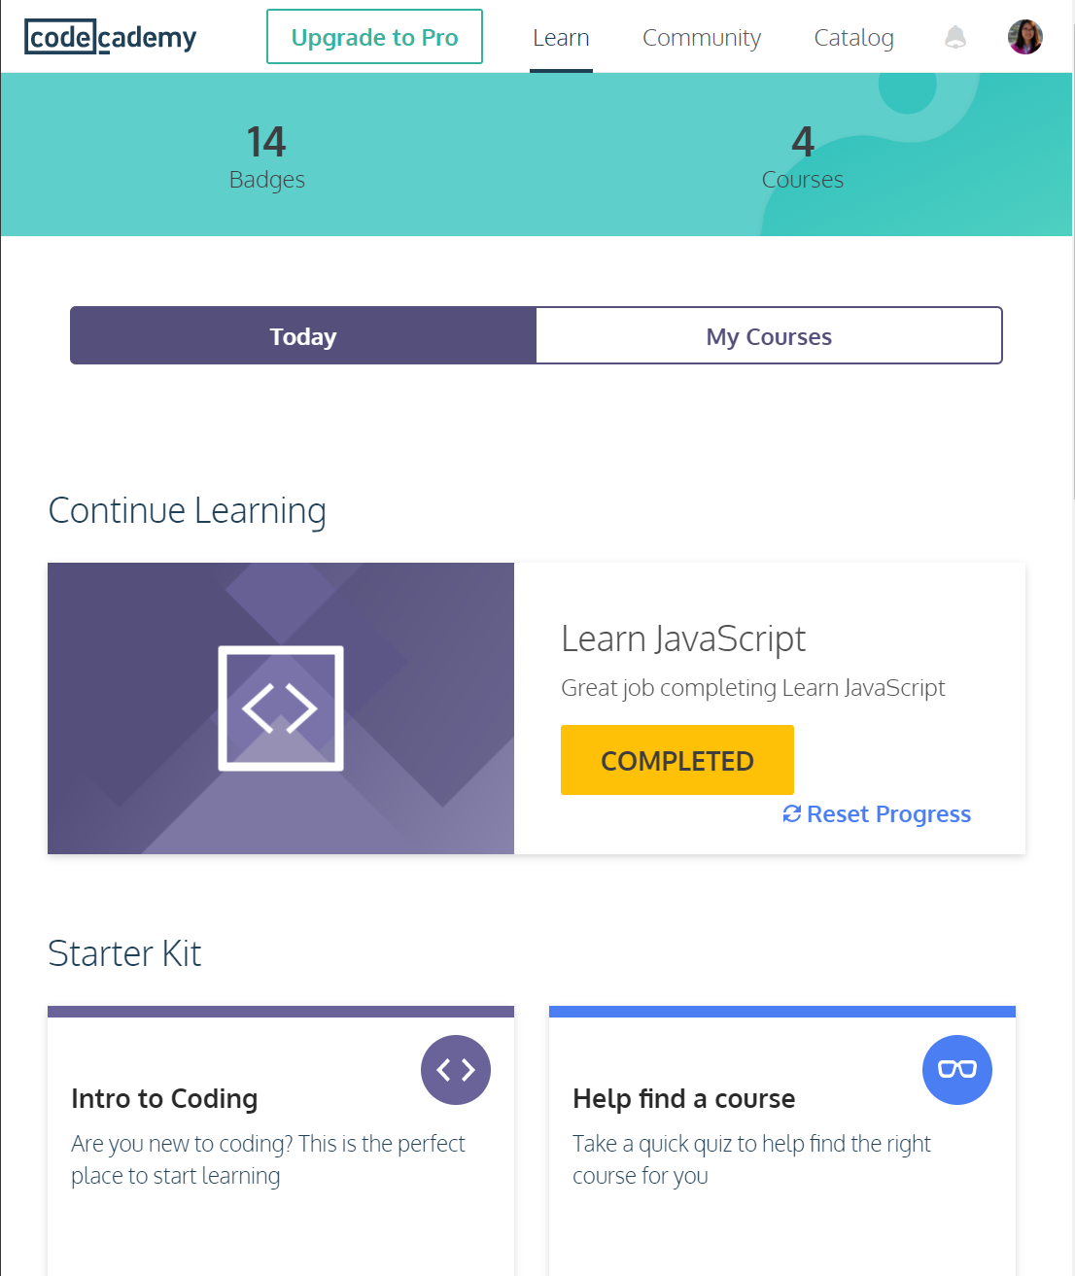

Then, I learnt more about JavaScript through [Learn X in Y minutes](https://learnxinyminutes.com/docs/javascript/). This site is a journal to learn the main concepts of JavaScript. I googled almost everything, but some concepts like function currying and bound functions took me a long time to understand.

To fill in my understanding gap, I scanned through several JavaScript books. “You don’t Know JS’ is a series of books that I truly enjoyed. The author explained the concepts very carefully and had coding challenges for me to quickly apply my knowledge. Besides that, Jon Duckett’s JavaScript books is another favorite of mine. The book has lots of visual in terms of big typography, columns of details for each concept, and information trees. Reading book is an effective way to gain deeper understanding of concepts that I fail to grasp through googling and watching YouTube.

Through Udemy, I am taking 2 JavaScript courses. In the *Complete JS Course*, I learnt how to write functions, create loops, arrays, objects. The coding challenges were very helpful to understand each concept more deeply. However, I struggled because I did not fully understand how certain things work in certain ways. I did not have a deeper knowledge of why JavaScript functions that way. Thus, I took the course *JS: Understanding the Weird Parts*, which explains difficult concepts more in-depth. I am still in the process of finishing these courses and truly enjoy my studying process. I learnt that coding is about breaking big problems into smaller actionable steps. Before coding a solution to a challenge, I found it important to understand the problem, write pseudo code, or at least think through about how to structure my steps. Through *Galvanize Web Development Immersive*, my goal is to learn the thinking process of a developer and build a strong portfolio.

These efforts took me two to three months studying part time. I did not just study HTML, CSS, and JS but also tried to learn git, git hub, and basic algorithm. My learning process is not glorious because I constantly had to search for good materials. I spent hours struggling with coding challenges and trying to understand concepts. However, I felt that I am more capable of learning new materials more effectively. I adopted a mindset that difficult CS concepts are learnable.

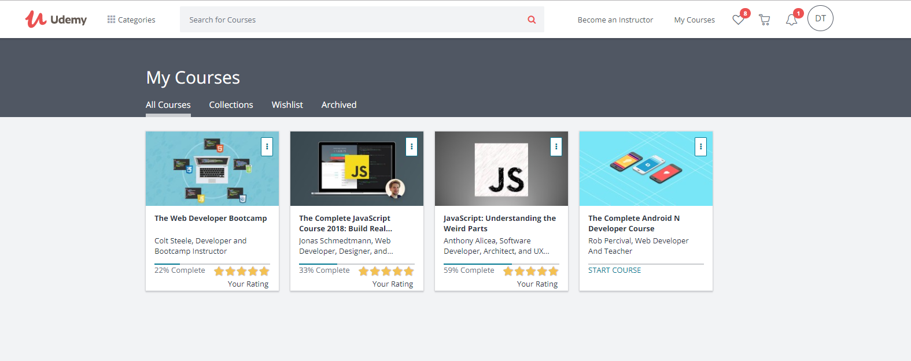

I also want to learn more about app development in the future, after mastering web development. These are pictures of a very simple GeoQuiz app that I made by following the *Big Nerd Ranch* app development book.

A screenshot of a cell phone

Description generated with very high confidenceA screenshot of a cell phone

Description generated with very high confidence